Jennifer Daniel

CIT480

Chapter 13 Exercises

**Exercise 13-1:**

13-1 Part 1/2:

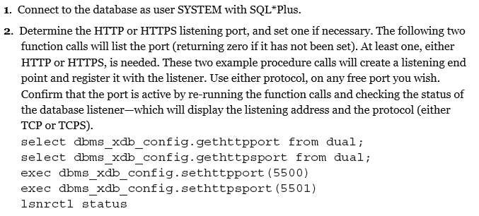

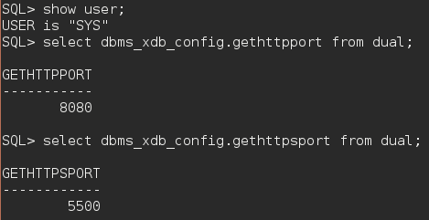

13-1 Part 3:

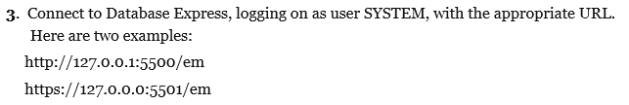

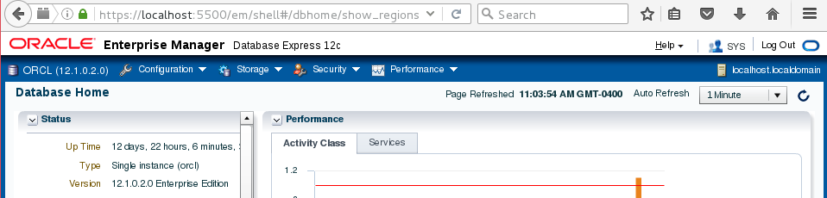

13-1 Part 4:

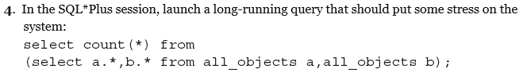

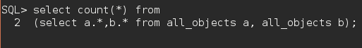

13-1 Part 5:

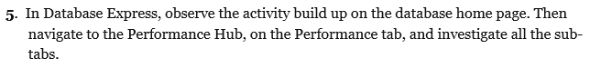

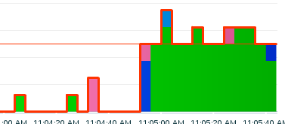

**Exercise 13-2:**

13-2 Part 1/2:

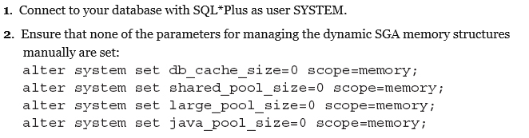

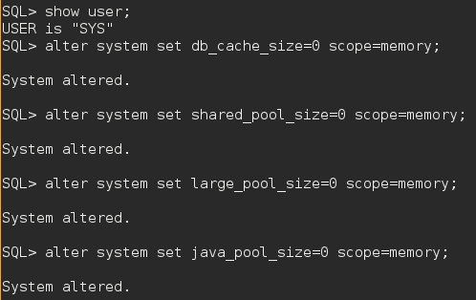

13-2 Part 3:





13-2 Part 4:

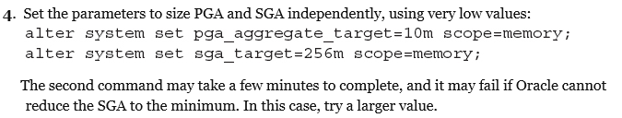

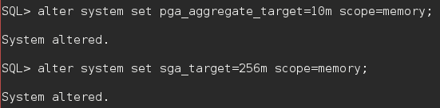

13-2 Part 5:

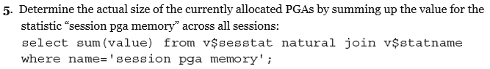

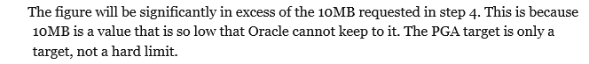

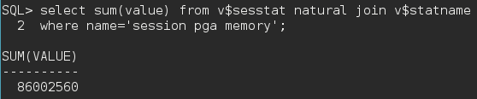

13-2 Part 6:

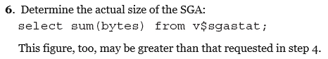

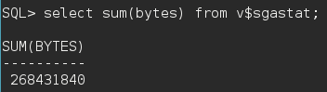

**Exercise 13-3:**

13-3 Part 1/2:

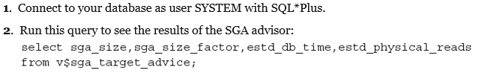



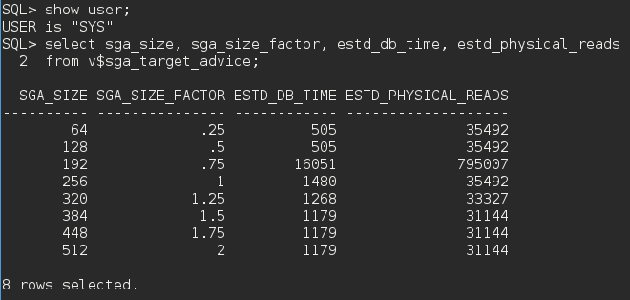

13-3 Part 3:

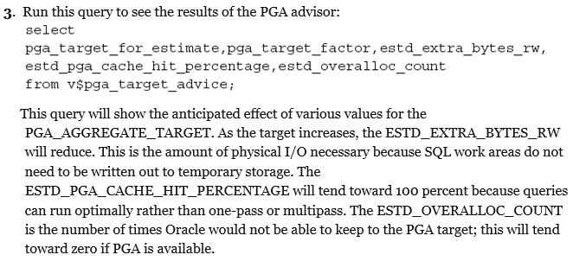

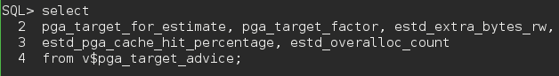

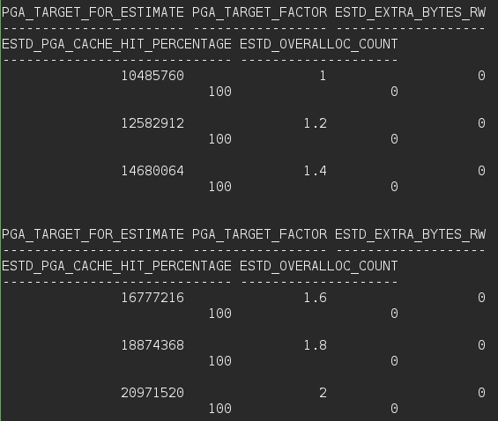

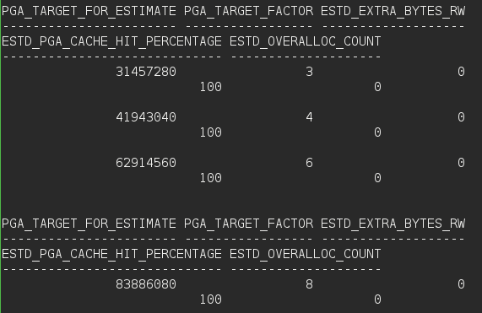

13-3 Part 4:

